**Deen Dayal Upadhyaya College**

**University of Delhi**

**AI Practicals**

**Name: Amit Kumar Nishad**

**Roll No: 21HCS4112**

**Paper Code: 32341601**

**Semester: 6th**

**Course: B.Sc. (H) Computer Science**

**Examination Roll Number: 21015570011**

**--------------------------------------------------------------------------------------------**

**Q1.** Write a program in the prolog to implement TowerOfHanoi(N) where N represent number of disk.

Ans :-

**CODE :-**

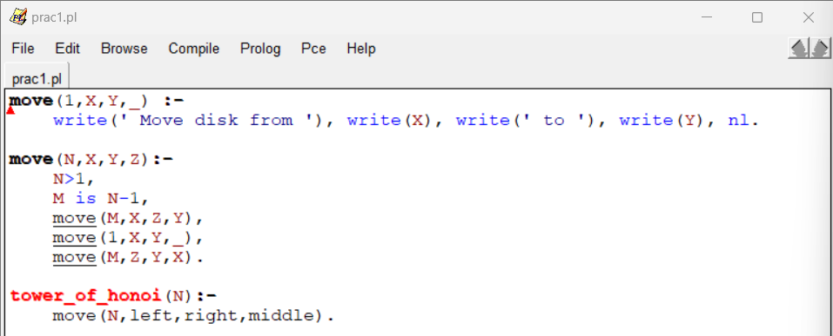

**OUTPUT :-**

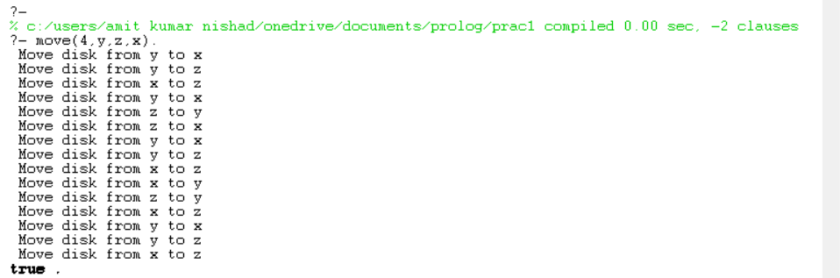

**TRACE OUTPUT :-**

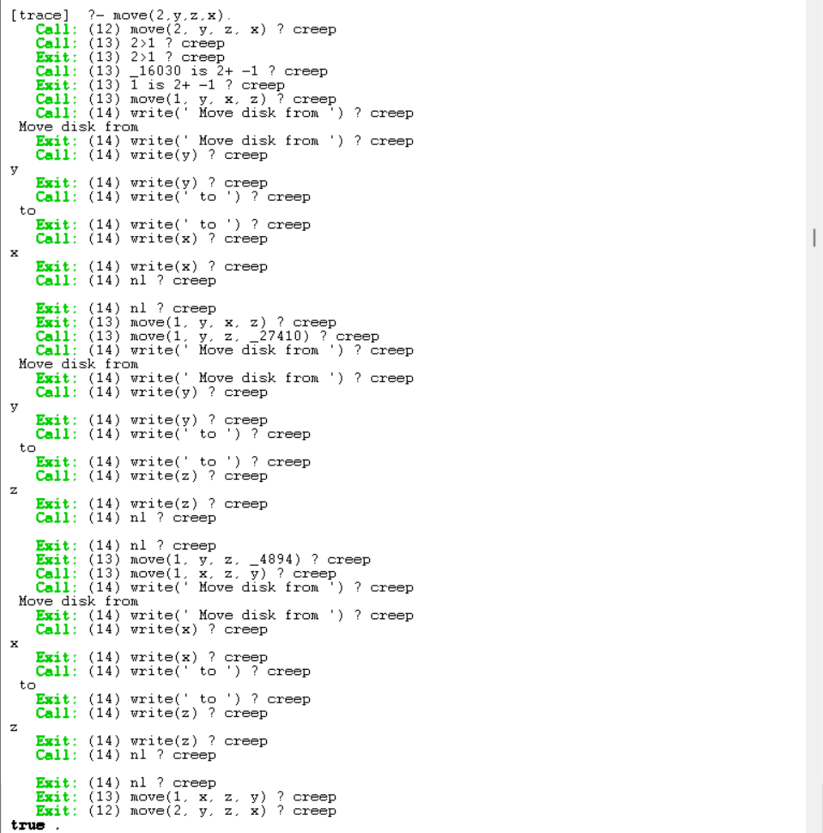

**Q2.** Write a program to implement Hill Climbing search algorithm in prolog.

Ans :-

**CODE :-**

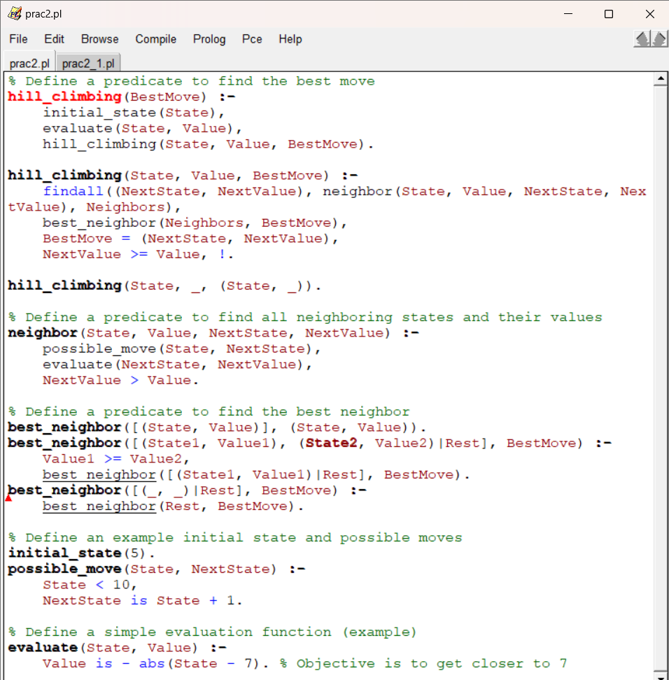

**OUTPUT :-**



**TRACE OUTPUT :-**

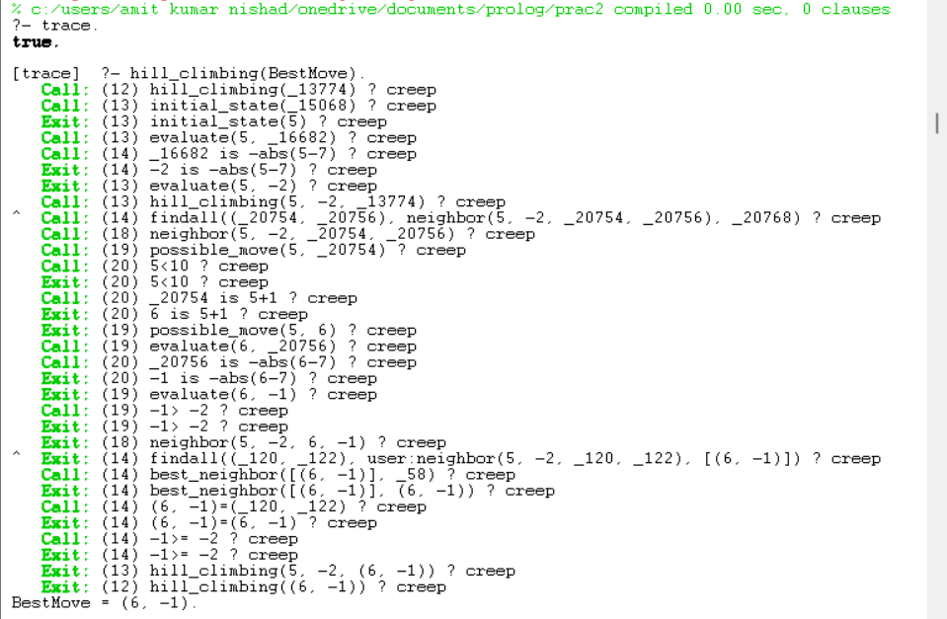

**Q3.** Write a program to implement best first search algorithm in prolog.

Ans :-

**CODE :-**

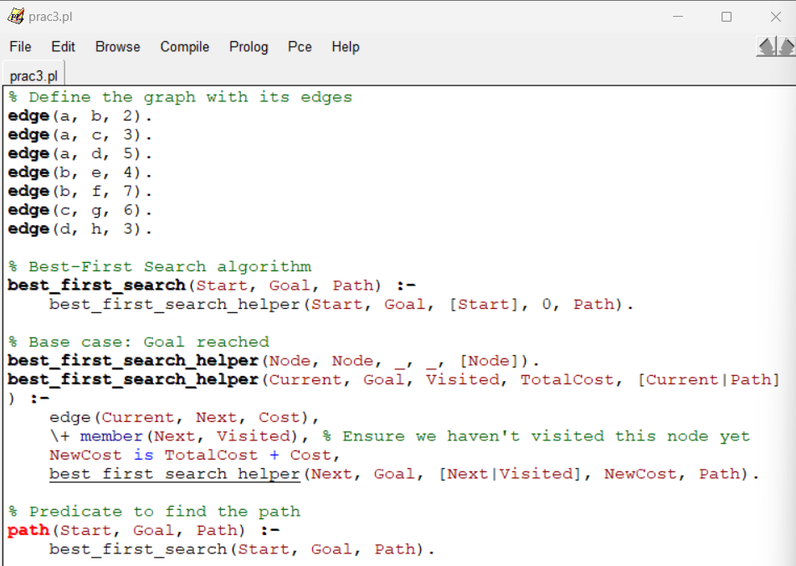

**OUTPUT :-**



**TRACE OUTPUT :­-**

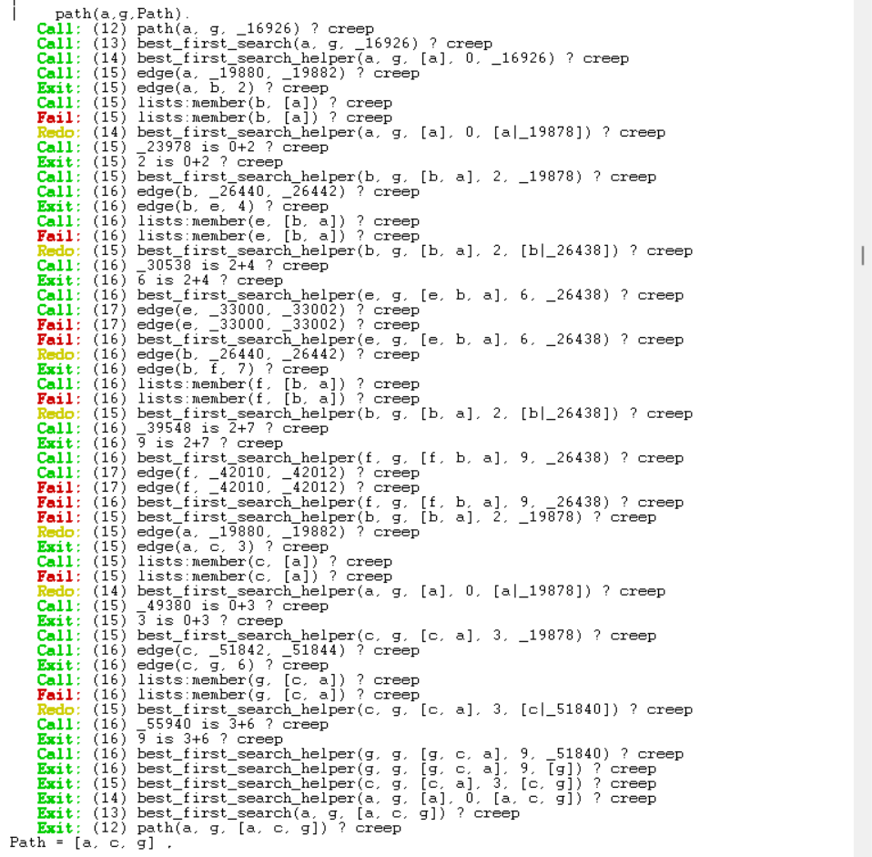

**Q4.** Write a program to implement A* search algorithm in prolog.

Ans :-

**CODE :-**

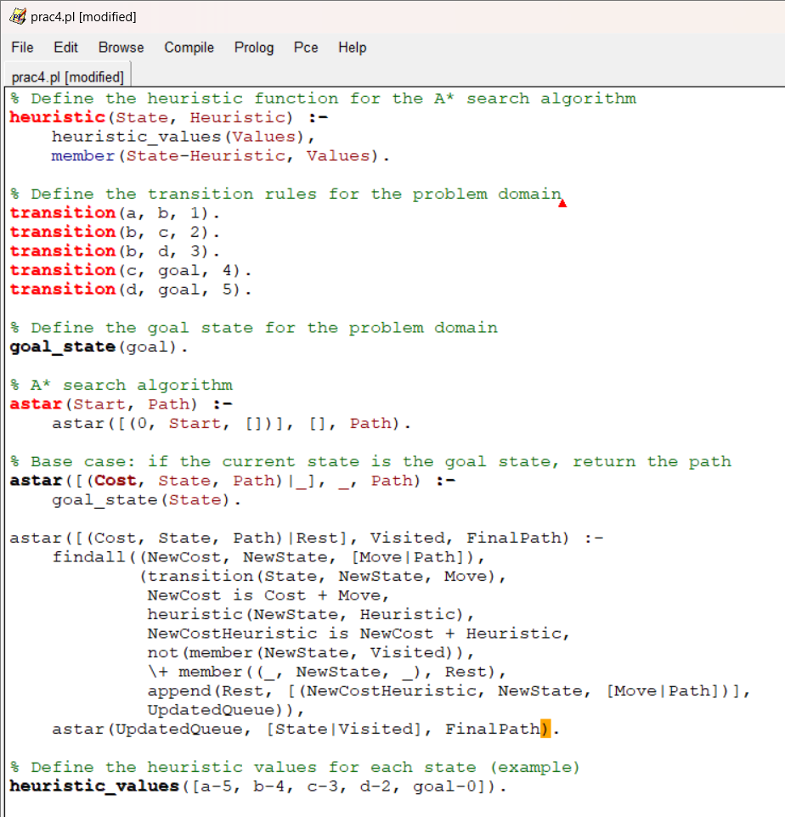

**OUTPUT :-**

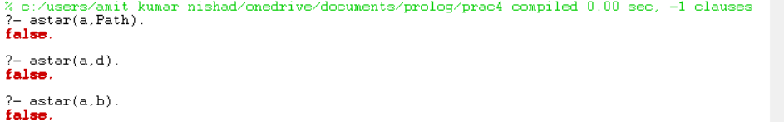

**TRACE OUTPUT :-**

**Q5.** Write a program to implement min max search algorithm in prolog.

Ans :-

**CODE :-**

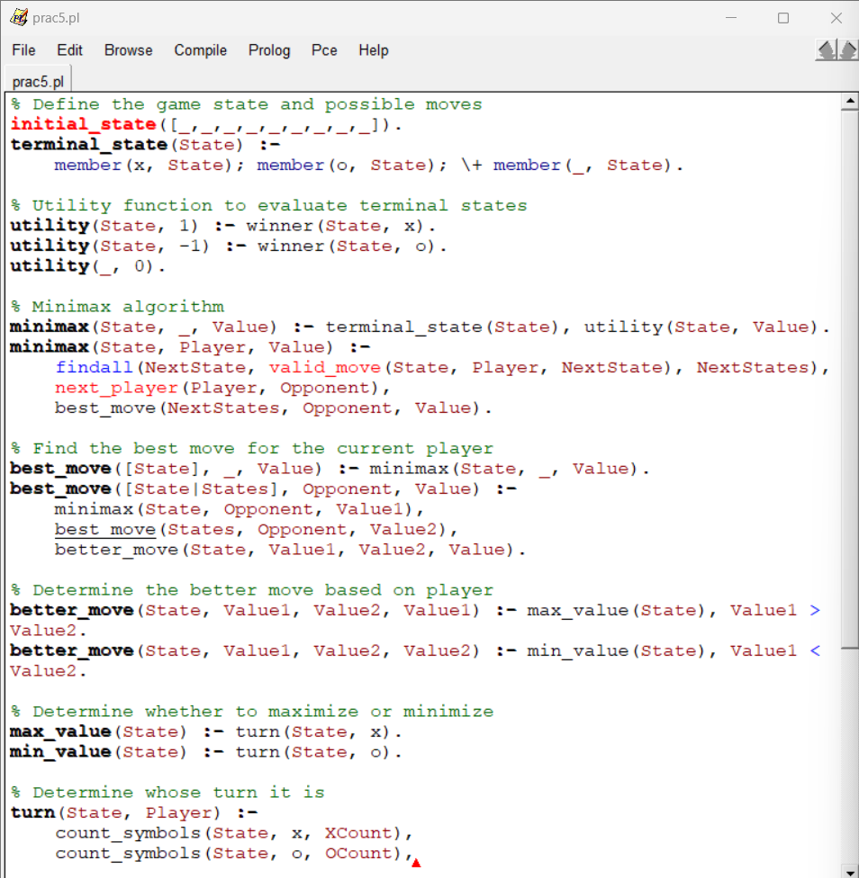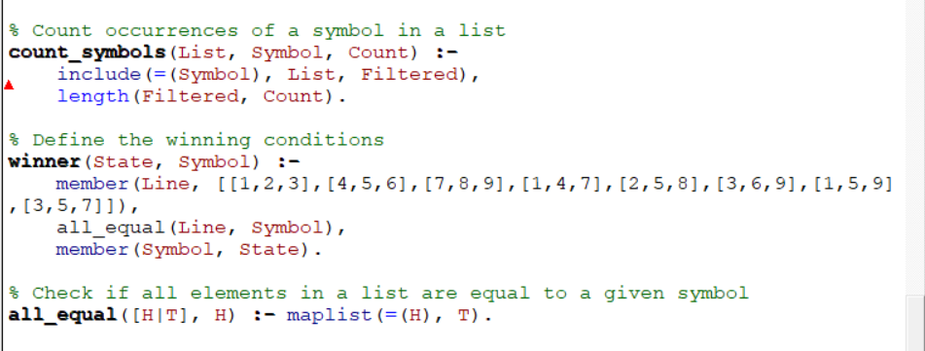

**OUTPUT :-**



**TRACE OUTPUT :-**

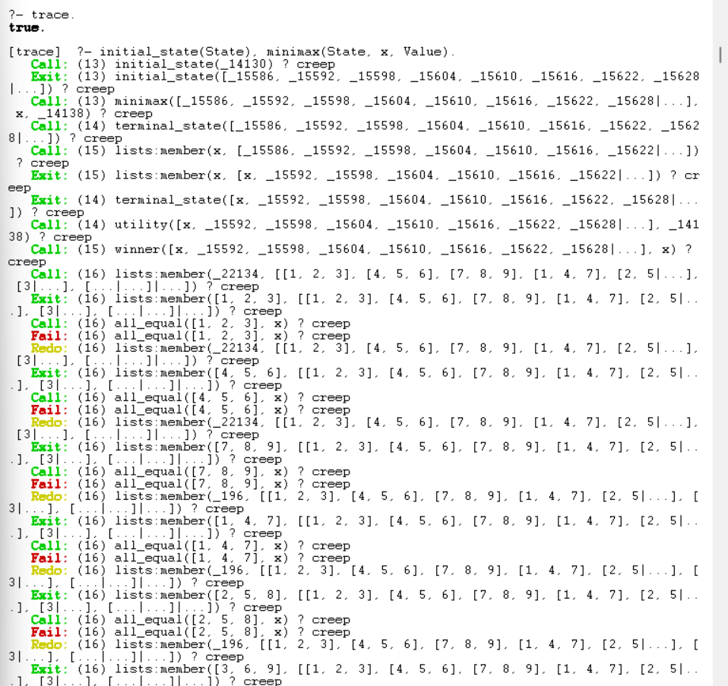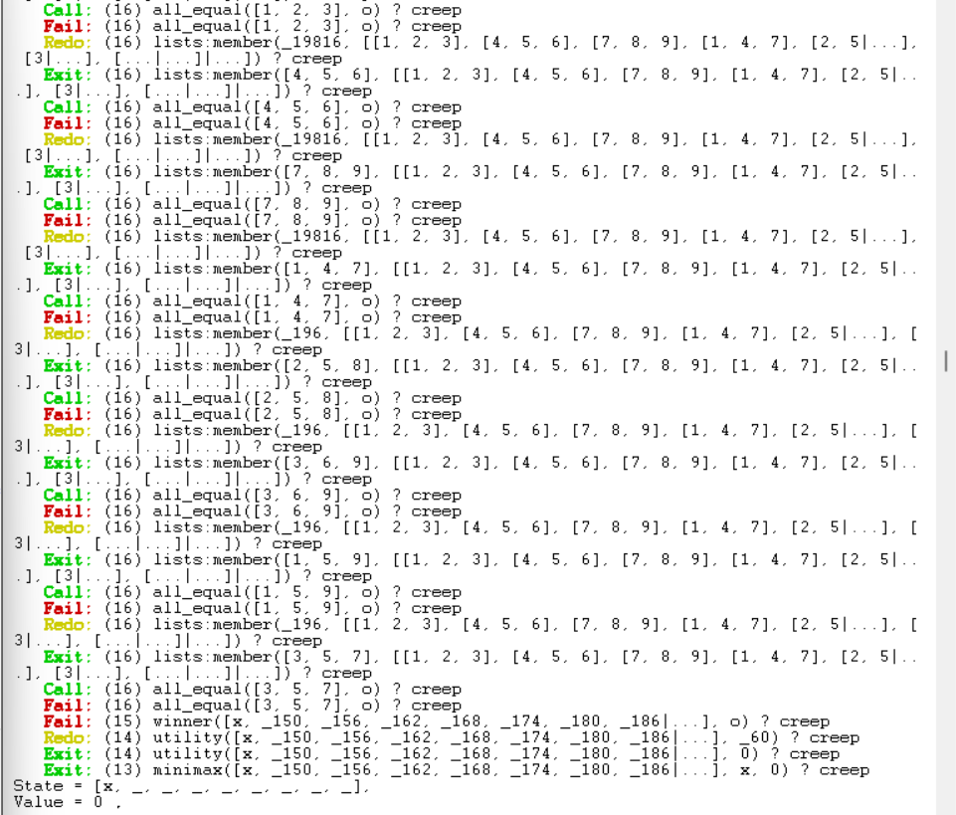

**Q6.** Write a program to solve Water Jug problem in prolog.

Ans :-

**CODE :-**

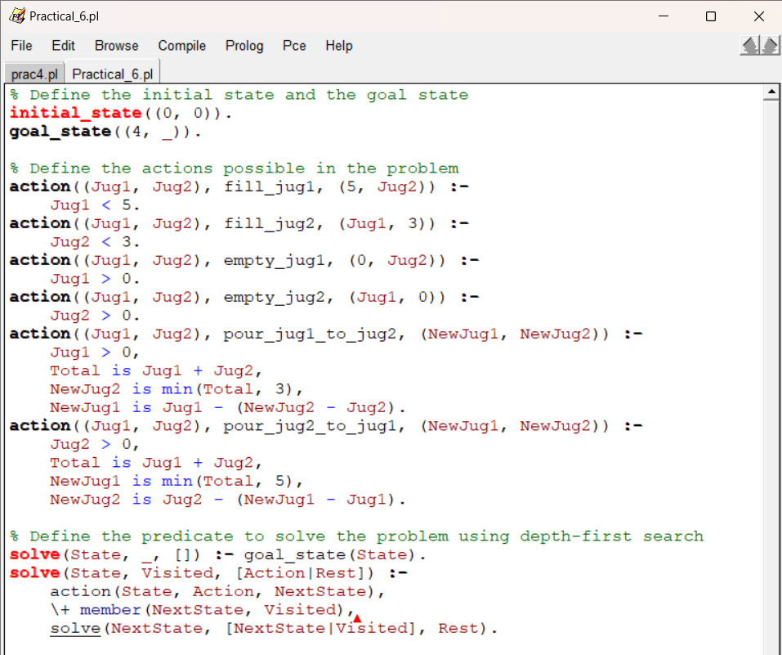

**OUTPUT :-**

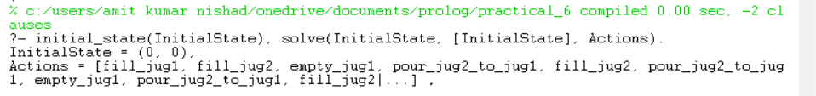

**TRACE OUTPUT :-**

**Q7.** Implement sudoku problem (minimum 9*9 size) constraint satisfaction in prolog.

Ans :-

**CODE :-**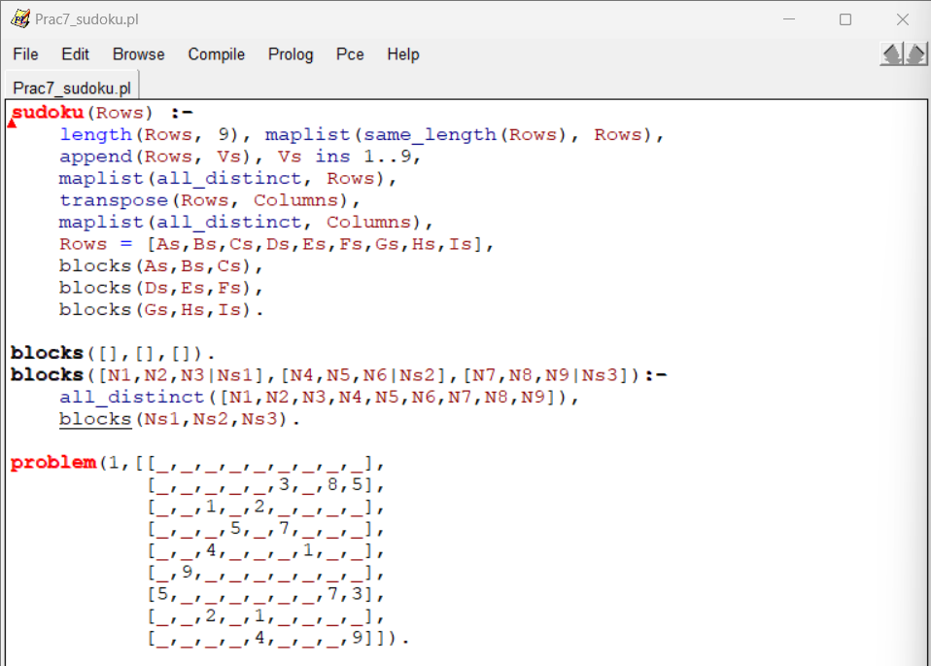

**OUTPUT :-**

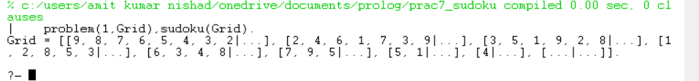

**TRACE OUTPUT :-**

**Q8.** Write a prolog program to implement family tree and demonstrate family relationship.

Ans :-

**CODE :-**

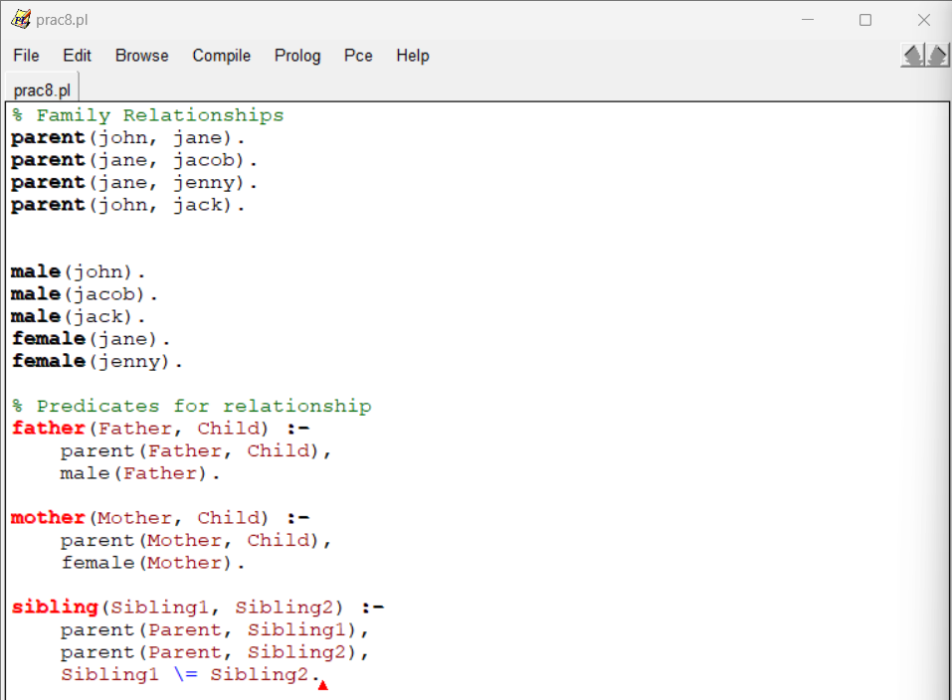

**OUTPUT :-**

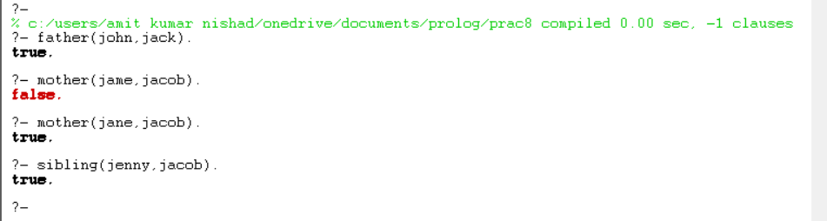

**TRACE OUTPUT :-**

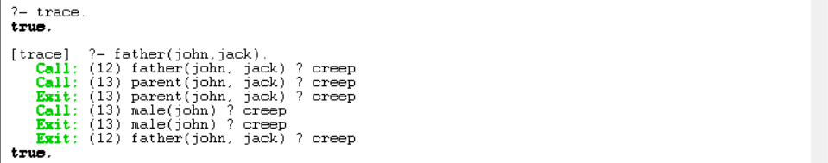

**Q9.** Write a prolog program to implement knowledge representation using frames with appropriate example.

Ans :-

**CODE :-**

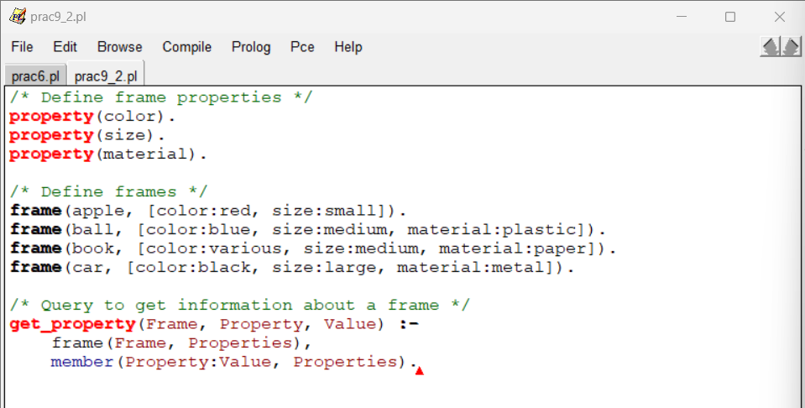

**OUTPUT :-**

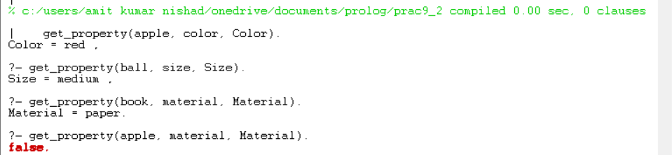

**TRACE OUTPUT :-**

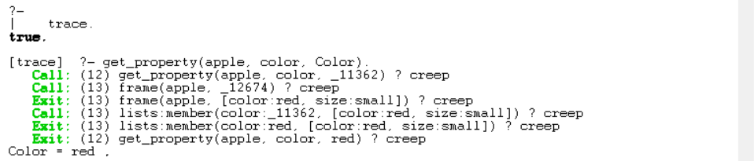

**Q10.** Write a prolog program to implement conc (L1,L2,L3) where append with L1 to get resulted list L3.

Ans :-

**CODE :-** 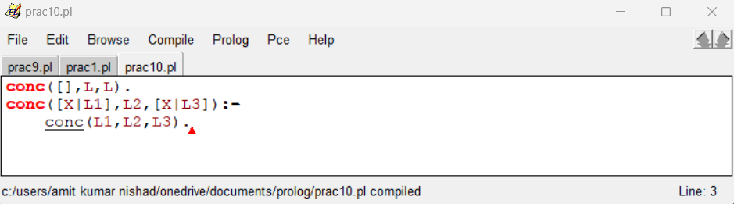

**OUTPUT :-**

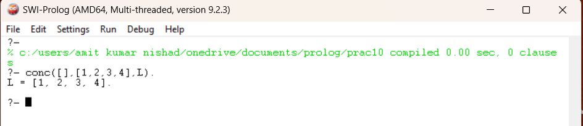

**TRACE OUTPUT :-**

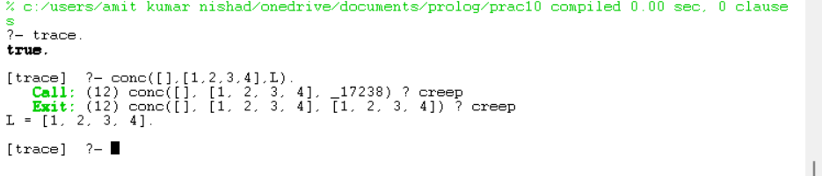

**Q11.** Write a prolog program to implement reverse (L,R) where list L is reversed list.

Ans :-

**CODE :-**

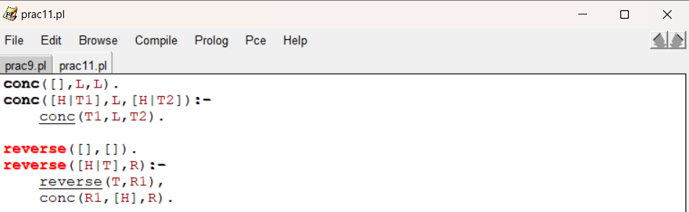

**OUTPUT :-**



**TRACE OUTPUT :-**

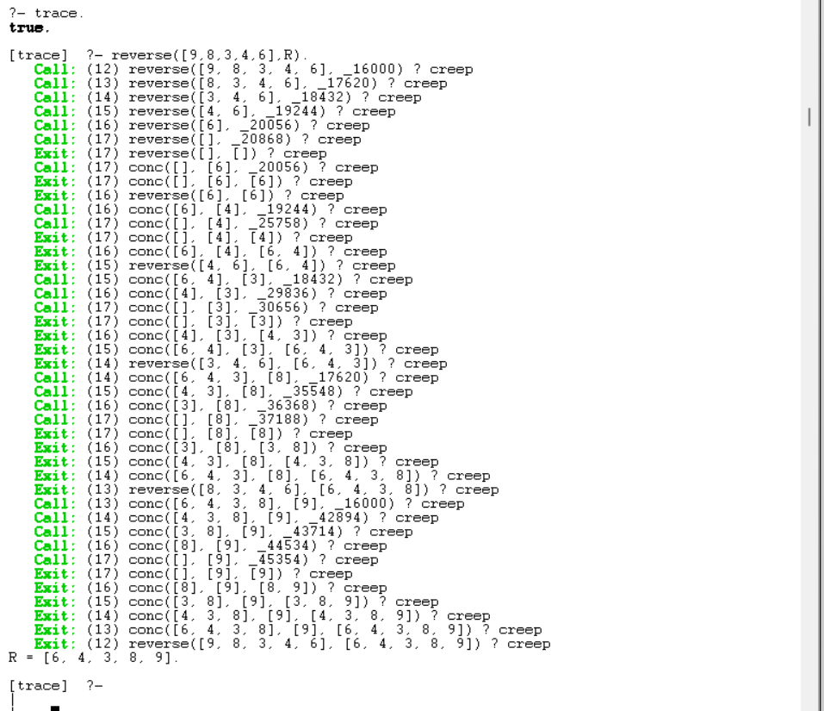

**Q12.** Write a prolog program to generate a parse tree of a given sentence assuming the grammar required for parsing.

Ans :-

**CODE :-**

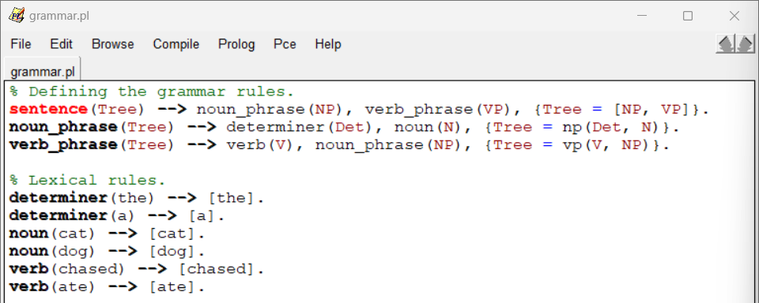

**OUTPUT :-**



**TRACE OUTPUT :-**

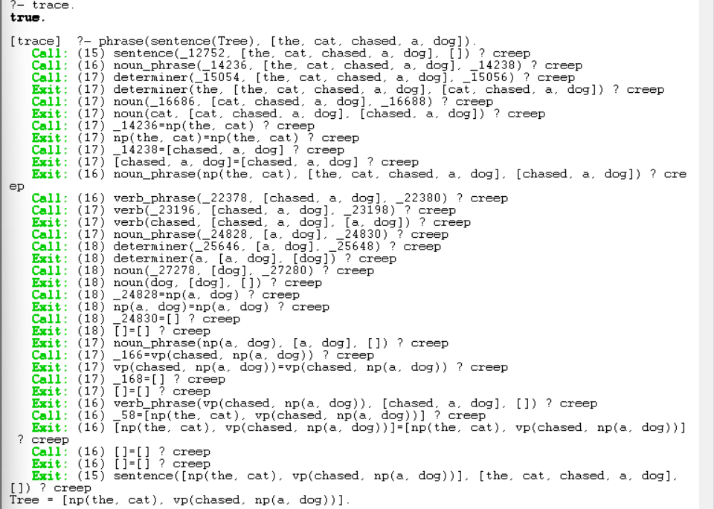

**Q13.** Write a prolog program to recognize context free grammer a^n b^n.

Ans :-

**CODE :-**

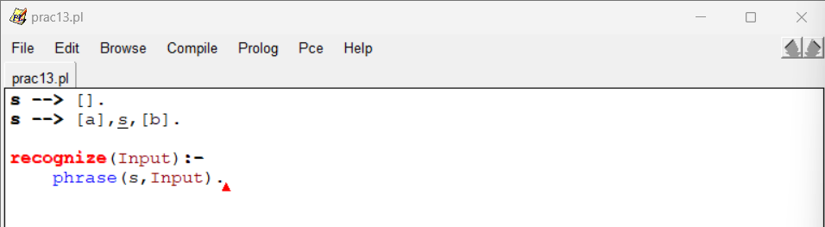

**OUTPUT :-**

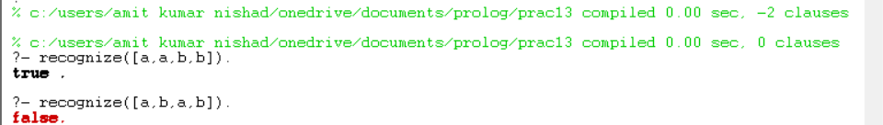

**TRACE OUTPUT :-**

